Opening balance 2023
Community Account = £9340.49
Saving account = £4035.57
1.Balance brought forward from 2022-2023 £13,376.06
2.Precept received - £6750.00
Receipts – Money in £9673.59
£48.59 Interest on saving account
£1076.00 Fundraising Money from Village Day and Quiz money
£1034.00 Money in from village hall
£1800.00 Refund on speed indicator device
Donations
£500.00 T H Moss & Sons Ltd
£1000.00 Steadings Holiday Park
CIL Money in £1800.00
CIL Money £2415.00
STAFF COSTS - £2346.60
05/06/2023 HMRC £123.40
05/06/2023 WAGES £494.10
04/09/2023 WAGES £493.90
04/09/2023 HMRC £123.60
04/12/2023 HMRC £123.60
04/12/2023 WAGES £494.10
Payments = £7081.45
04/05/2023 | 100478 | £133.20 | Planters opposite Fox
02/05/2023 | 100481 | £53.98 | Clerk -Printer Ink
18/05/20023 | 100480 | £156.00 | Training
03/07/2023 | 100484 | £200.00 | Church Roof donation
07/08/2023 | 100485 | £100.98 | ESC Uncontested election
07/08/2023 | 100486 | £50.00 | Greener Waldringfield
07/08/2023 | 100487 | £116.17 | Internet - Village Hall 50% Contribution
04/09/2023 | 100488 | £156.45 | SALC Membership 2023 -2024
04/09/2023 | 100491 | £2,068.00 | Insurance
02/10/2023 | 100492 | £98.40 | Play safety - playground inspection
02/10/2023 | 100493 | £54.98 | Clerk Printer ink
04/12/2023 | 100496 | £22.80 | SALC Payroll
08/01/2024 | 100498 | £780.00 | AJS Services Grass cutting 2023- Jan 2024
08/01/2024 | 100499 | £2,807.99 | Elan City - Speed indicator device
05/02/2024 | 100501 | £112.50 | Noble Nature - bus shelter repairs
05/02/2024 | 100502 | £170.00 | AJS Services Put up Speed Camera / take away rotten wood play area

Closing balance - £20,371.60

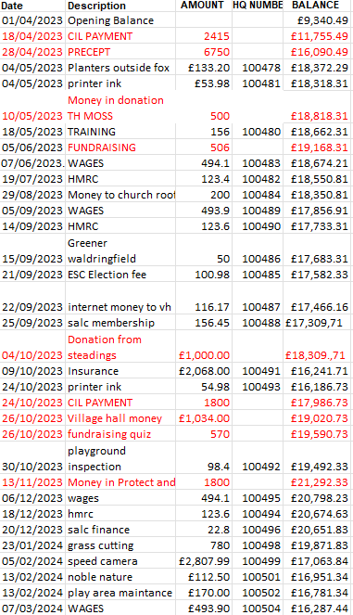
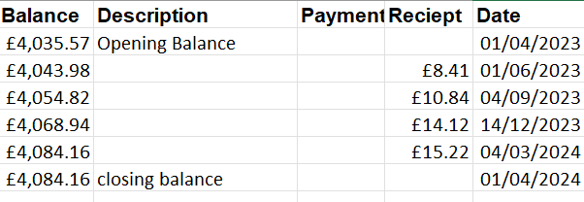

Audit
1.Balance brought forward 2022-2023+ £13,376.06
2.Precept + £6750.00
3.Receipts money in £9673.59
Total £29,799.65
Minus
4.Staff costs £2347.00
5. Loan Repayments £0.00
6. Other payments £7081.45
Total £20,372

2023-2024 Receipts for year £16,423
2023-2024 Payments for year £16,760

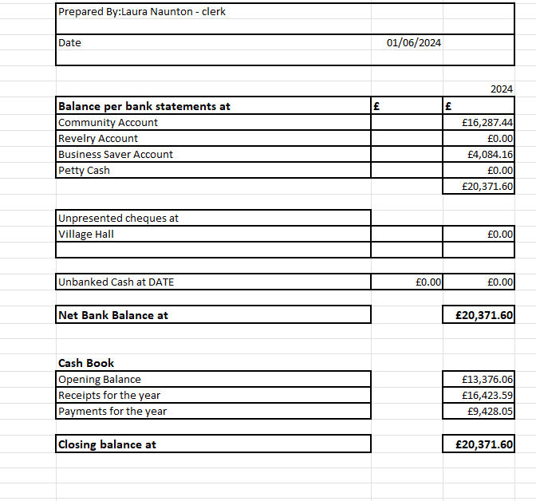
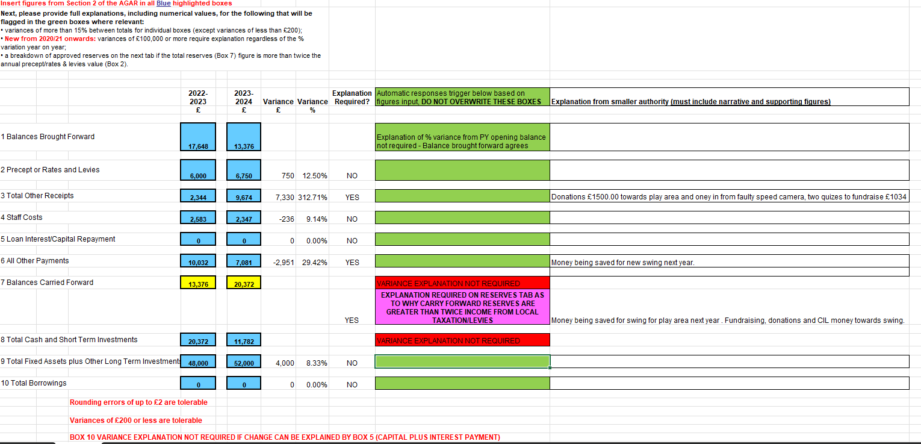
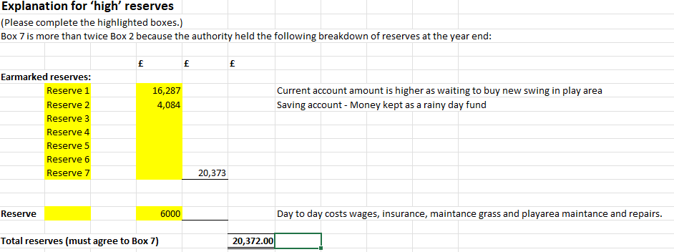

Asset Register 2023-2024
Description | Location | Date brought | Cost | value | Insurance Value
Village Hall | Mill road , Newbourne | 1985 | £2000.00 | £2000.00 nominal | £350.000
Play area | Village hall grounds | 2010 | £44,000 | £44,000 | £40,000
Bus Shelter | Opposite fox pub | Pre 1980 | Not known | £1 nominal | Outside furniture policy
Park bench | Village hall | 2012 | £800.00 | £800.00 | Outside furniture policy
Newbourne village sign | Centre of village | 2006 | £3094.00 | £3094.00 | Outside furniture policy
3 grit bins | Mill road, jackson road, Ipswich road | 2013 | £406.00 | £406.00 | Outside furniture policy
Litter bin | Village hall gounds | 2014 | £240.00 | £240.00 | Outside furniture policy
Sign | Village hall grounds | 2014 | £183.00 | £183.00 | Outside furniture policy
Notice Board | Outside village hall | 2020 | £1000.00 | £1000.00 | Outside furniture policy
Defibrillator | Outside pub | 2023 | £1500.00 | £1500.00 | £1200.00

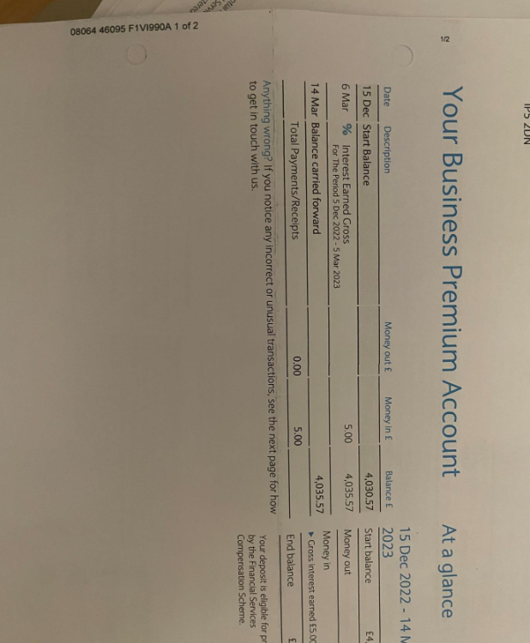
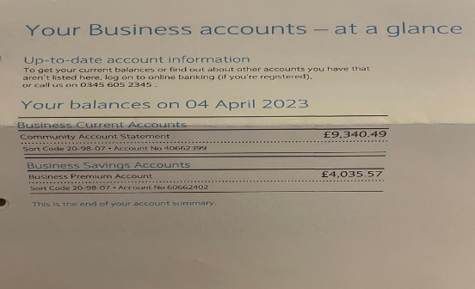
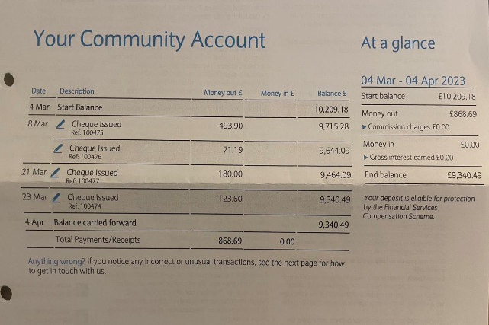
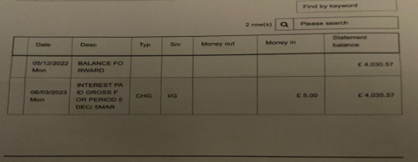
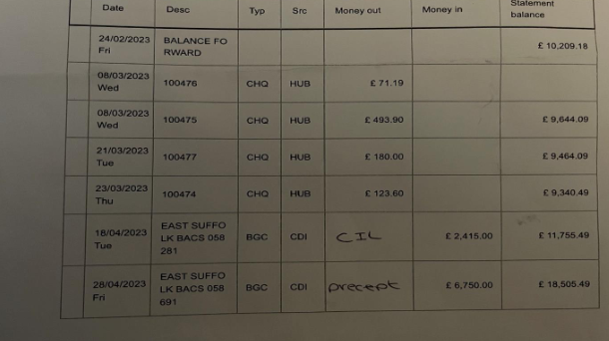
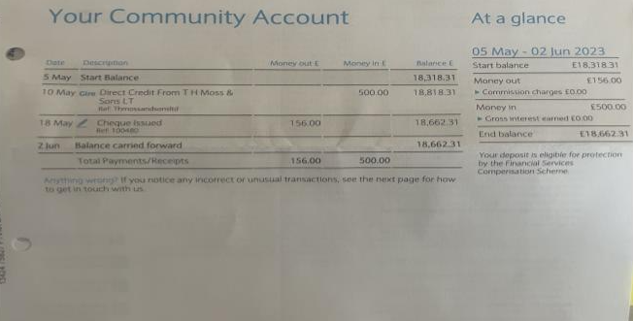
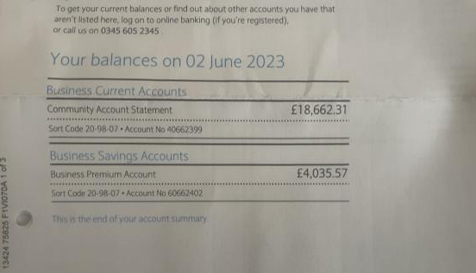
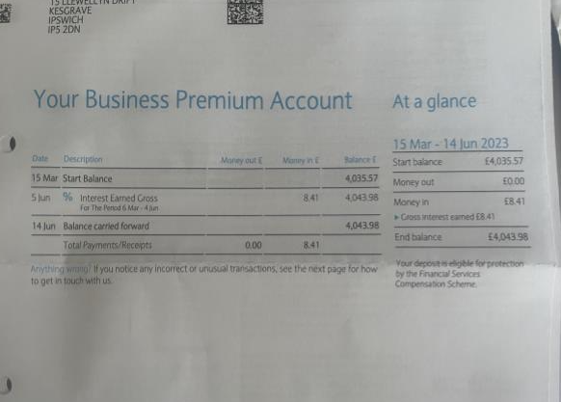
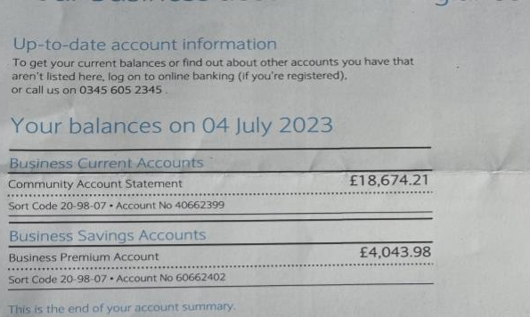
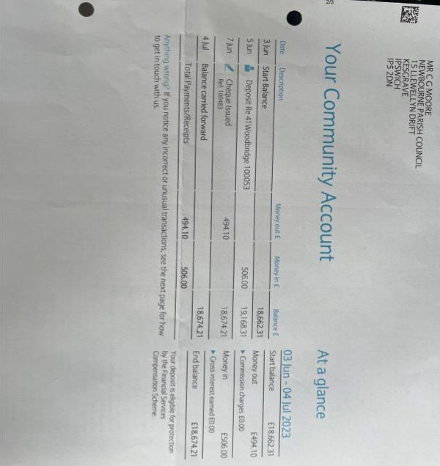
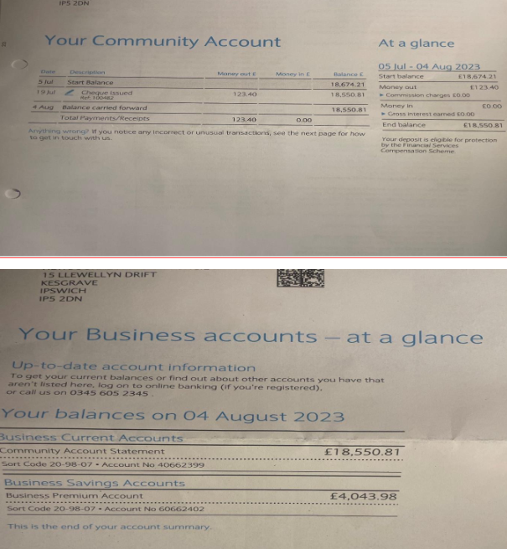
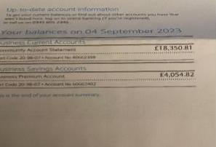
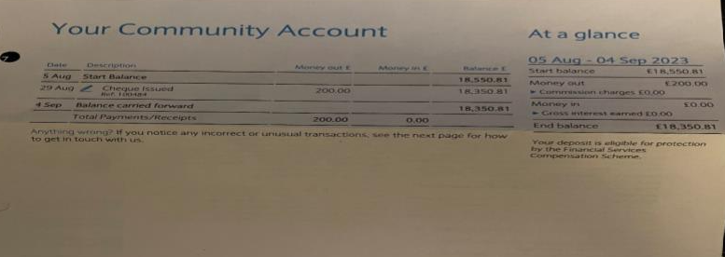
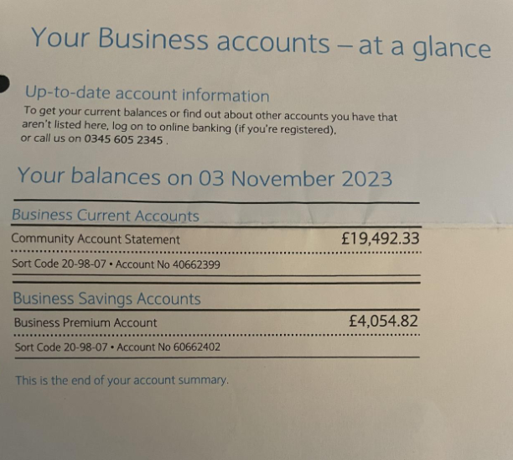
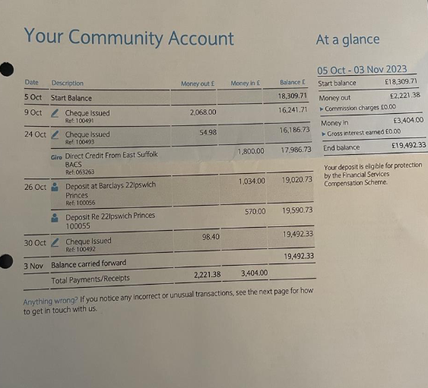
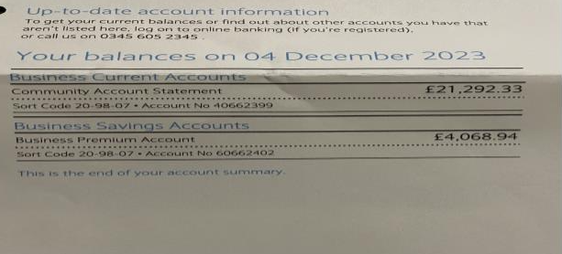

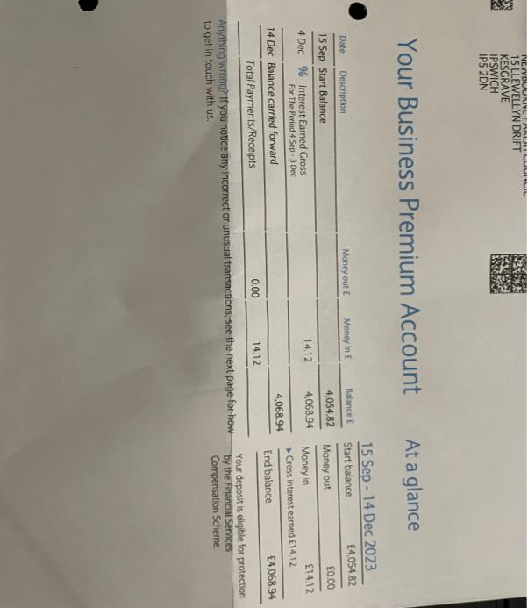
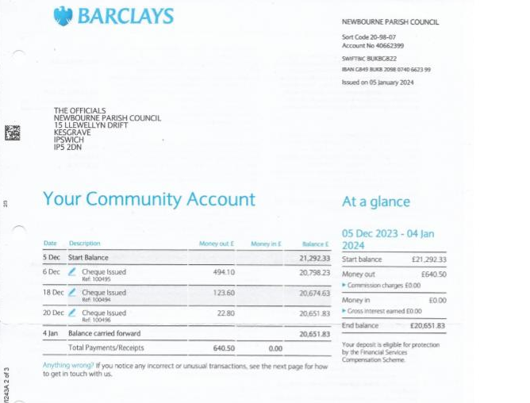

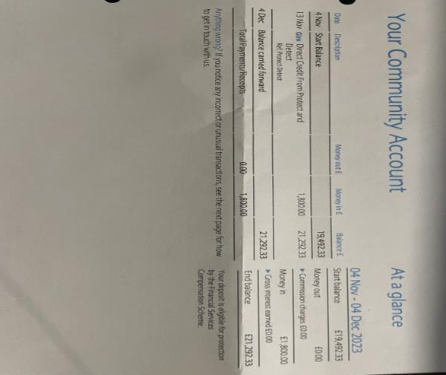
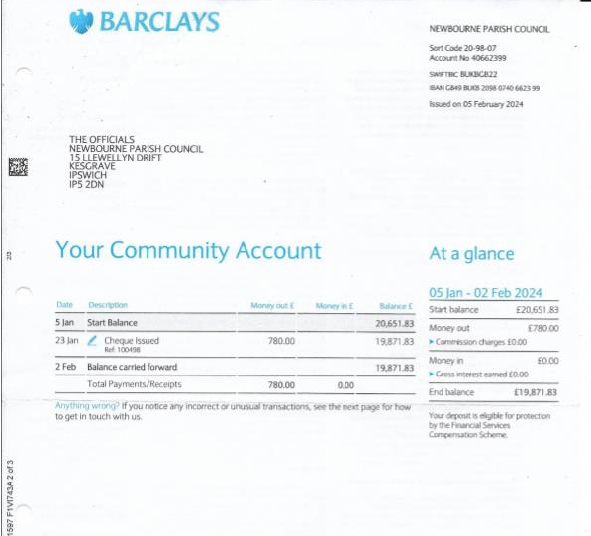
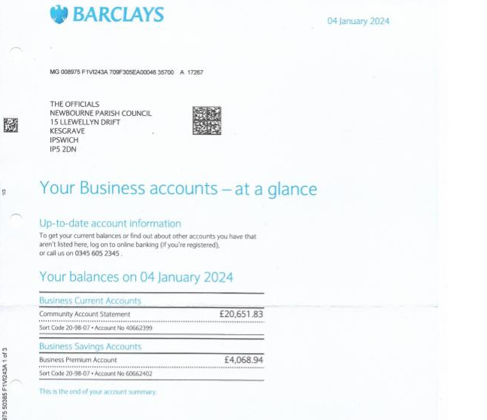
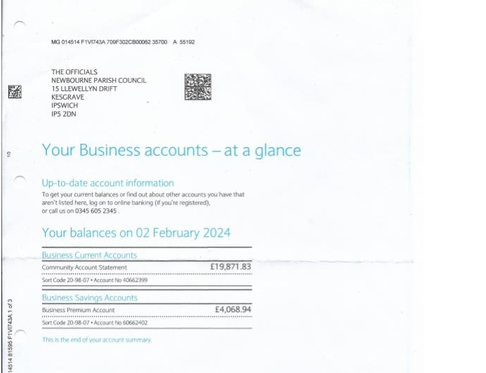
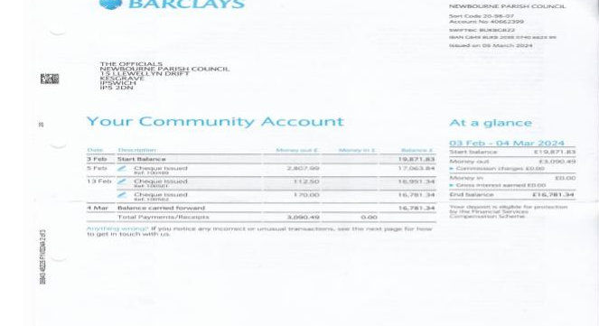
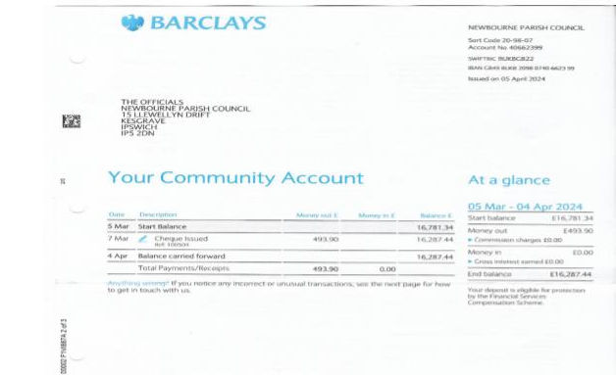
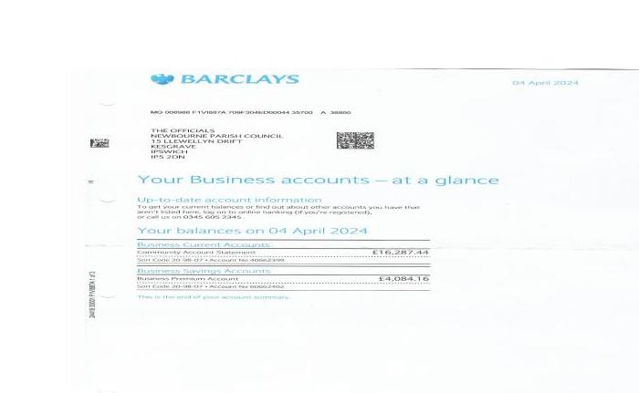

 |  | Amount | Payment Reason
02/05/2023 | 100481 | £53.98 | Clerk -Printer Ink
05/06/2023 | 100482 | £123.40 | HMRC
05/06/2023 | 100483 | £494.10 | Clerks Wages Feb - May
03/07/2023 | 100484 | £200.00 | Church Roof donation
07/08/2023 | 100485 | £100.98 | ESC Uncontested election
07/08/2023 | 100486 | £50.00 | Greener Waldringfield
07/08/2023 | 100487 | £116.17 | Internet - Village Hall 50% Contribution
04/09/2023 | 100488 | £156.45 | SALC Membership 2023 -2024
04/09/2023 | 100489 | £493.90 | clerks wages june - August
04/09/2023 | 100490 | £123.60 | HMRC
04/09/2023 | 100491 | £2,068.00 | Insurance
02/10/2023 | 100492 | £98.40 | Playsafety - playground inspection
02/10/2023 | 100493 | £54.98 | Clerk Printer ink
04/12/2023 | 100494 | £123.60 | HMRC September-November
04/12/2023 | 100495 | £494.10 | Clerks wages September - November
04/12/2023 | 100496 | £22.80 | SALC Payroll
08/01/2024 | 100497 | £52.09 | Internet - Village Hall 50% Contribution
08/01/2024 | 100498 | £780.00 | AJS Services Grass cutting 2023- Jan 2024
08/01/2024 | 100499 | £2,807.99 | Elan City - Speed indicator device
05/02/2024 | 100501 | £112.50 | Noble Nature - bus shelter repairs
05/02/2024 | 100502 | £170.00 | AJS Services Put up Speed Camera / take away rotten wood play area

2023 -2024
Money In
£6750.00 Precept
£53.59 Interest on saving account
£1076.00 Fundraising Money from village Day and quiz money
£1034.00 Money in from village hall
£1800.00 Refund on speed indicator device
Donations In
£500.00 T H Moss & Sons Ltd
£1000.00 Steadings Holiday Park
CIL Money in
£1800.00
£2415.00
Money Out
Wages - £2469.90
HMRC - £494.20
Grass Cutting £1130.00
Noble Nature £112.50
Defib tracker /printer ink £180.15
Planters £133.20
Training £156.00
Donation £200.00
Membership Greener Waldringfield £50.00
ESC Election £100.98
Internet 116.17
Salc membership £156.45
Insurance £2068.00
Playarea safety inspection £98.40
Salc payroll £22.80
Speed indicator device £2807.99
Predicted Spend 2024 – 2025
Wages £1976.00
HMRC £494.20
SALC Membership £156.45
SALC PAYROLL £91.20
Grass Maintenance £1000.00
Insurance £2300.00
Playground inspection £98.40
CAS Website £60.00
Internet £120.00

