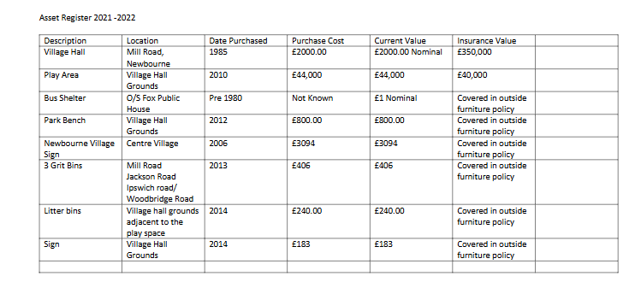
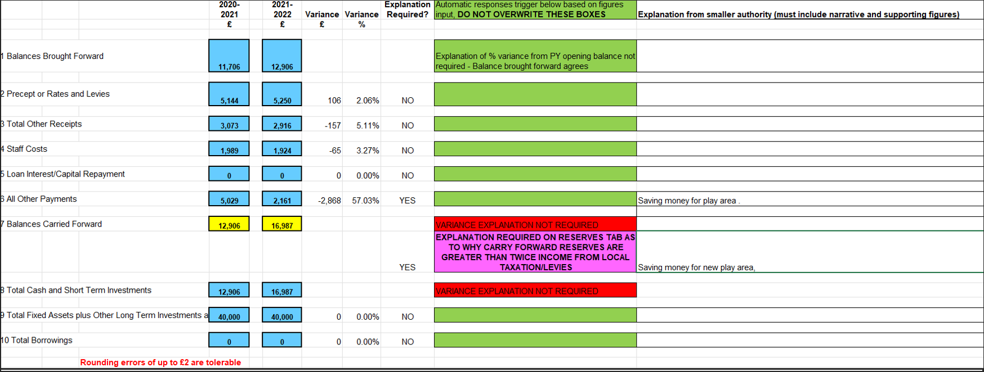

Community Account
Opening Balance £12,960.33
30/04/2021 £5450.00 Precept + £17.00 ESC Grant £18,427.33
28/05/2021 £453.60 Wages £17,973.73
01/06/2021 £453.60 Wages £17,520.13
07/06/2021 £640.38 Money in from VH £18,160.51
08/06/2021 £113.20 HMRC £18,047.31
08/06/2021 £113.40 HMRC £17,933.91
11/06/2021 £60.00 SCL Grass £17,873.91
11/06/2021 £240.00 SCL Grass £17,633.91
08/09/2021 £453.40 Wages £17,180.51
24/09/2021 £144.41 SALC £17,036.10
24/09/2021 £120.00 SCL £16,916.10
24/09/2021 £22.80 SALC PAYROLL £16,893.30
07/10/2021 £120.00 SCL Grass £16,773.30
07/10/2021 £203.50 noticeboard £16,569.80
20/10/2021 £242.00 Noticeboard £16,327.80
20/10/2021 £94.80 Playground inspection £16,233.00
25/10/2021 £1513.68 Insurance £14,719.32
09/11/2021 £800.37 Village Sign Refurb £13,918.95
08/12/2021 £453.40 Wages £13,465.55
03/01/2022 £858.59 Money in Village Hall £14,324.14
07/02/2022 £113.40 HMRC £14,210.74
07/02/2022 £113.40 HMRC £14,097.34
18/02/2022 £22.80 SALC payroll £14,074.54
08/03/2022 £453.40 Wages £13,621.14

Saving Account
13/03/2021 £4026.38
07/06/2021 £4026.48
07/09/2021 £4026.58
07/12/2021 £4026.68
01/02/2022 £4026.78
04/04/2022 £4026.78
+40p
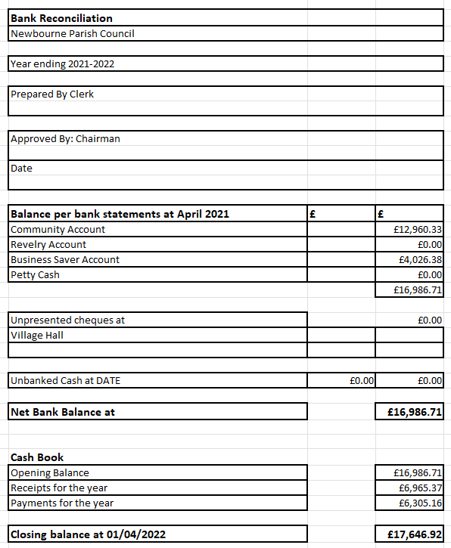
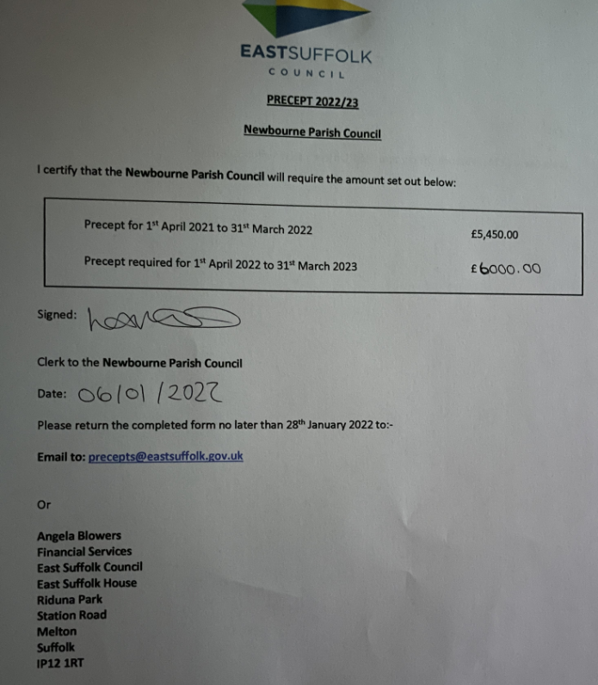
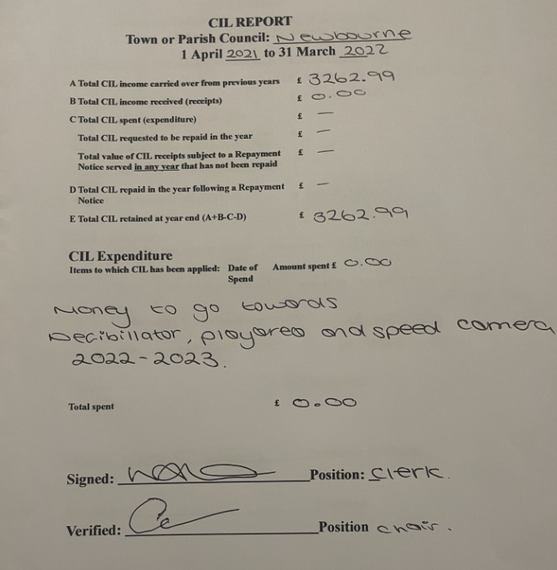

2021 -2022
Audit figures
1.Opening Balance £16,986.71
Community account £12.960.33
Saving account £4026.38
2.Precept - £5450.00
3.Receipts £1516.37
£17.00 Money from ESC
£640.38 -07/06/2021 Money in from village hall
£858.59 - 05/01/2022 Money in from village hall
No grants
NO CIL
0.40p Interest in saving amount
4.Staff Costs = £2720.80
28/05/2021 £453.60
01/06/2021 £453.60
08/09/2021 £453.40
04/12/2021 £453.40
08/03/2022 £453.40
08/06/2021 £113.40
08/06/2021 £113.20
07/02/2022 £113.40
07/02/2022 £113.40

5.Loan £0.00
6.All Payments made
£240.00 Grass
£60.00 Grass
£22.80 SALC Payroll
£120.00 Grass
£144.41 SALC
£120.00 Grass
£203.50 Notice board
£242.00 Notice board
£94.80 Playground inspection
£1513.68 Insurance
£800.37 Village sign refurb
£22.80 SALC Payroll
£3584.36

7. Balance £17,647.92
Community £13,621.14
Saver £4026.78

Receipts made 2021-2022 £6,965
Payments made 2021-222 £6305.16

