Finance 2020 – 2021
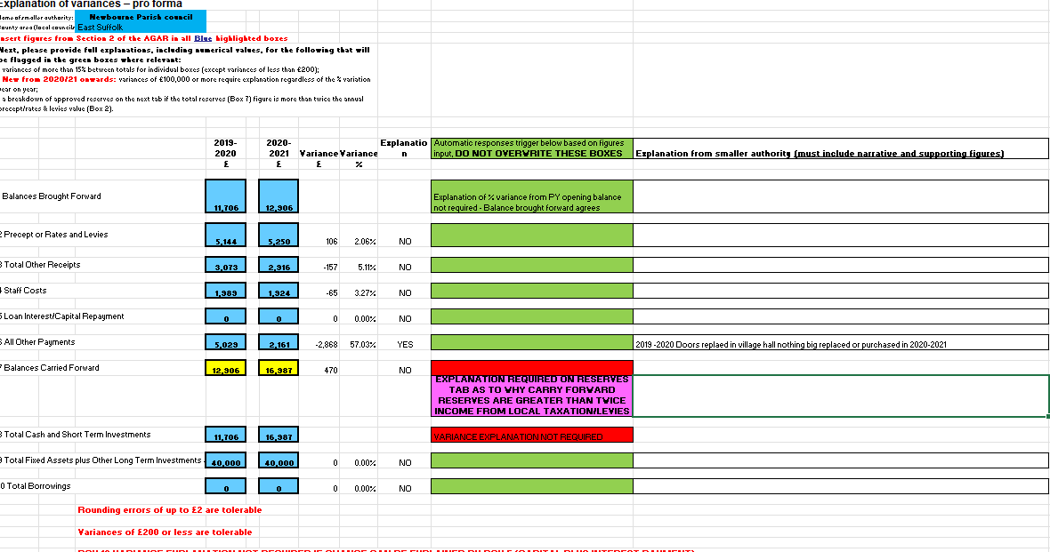

DATE AMOUNT PAYMENT DESCRIPTION CHEQUE NUMBER BALANCE
04/04/2020 £8881.52 Opening Balance
28/04/2020 £1813.95 Money in from East Suffolk Council £10,695.47
29/04/2020 £2625.00 Money in Precept from East Suffolk Council £13,320.47
31/07/2020 £1100.00 Money in Grant Money £14,420.47
04/08/2020 £453.60 Clerks Wages £13,966.87
04/08/2020 £110.60 HMRC £13,966.87
03/09/2020 £113.20 HMRC £13,856.27 18/09/2020 £453.60 Clerks wages May 2020 -August 2020 £13,289.67
21/09/2020 £140.71 SALC Membership £13,148.96
21/09/2020 £21.60 SALC PAYROLL £13,127.36
30/09/2020 £2625.00 Precept £15,752.36
01/10/2020 £1280.76 Insurance £14,471.60
03/10/2020 £113.40 HMRC May 2020 -August 2020 £14,358.20
07/10/2020 £300.00 SCL Grass Cutting £14,058.20
13/10/2020 £60.00 SCL Grass Cutting £13,998.20
09/12/2020 £94.80 Playground inspection ROSPA £13,903.40
15/12/2020 £113.47 HMRC Outstanding payment from previous year 100421 £13,313.73
15/12/2020 £453.40 Clerks Wages August 2020 – November 2020 100425 £13,336.53
21/12/2020 £22.80 SALC PAYROLL SERVICE £13,313.73
21/12/2020 £60.00 Community action Suffolk website £13,253.73
30/12/2020 £120.00 SCL Grass Cutting 100426 £13,133.73
01/02/2020 £113.40 HMRC August 2020 -November 2020 100424 £13,020.33
23/02/2020 £60.00 SCL Grass Cutting £12,960.33

Closing balance on account £12,960.33

- Opening Balance £12,906

Community account £8881.52
Saving £4024.54
Total £12,906.06
- Precept - £5250
- Receipts - £2916
28/04/2020 £1813.95 Money in from East Suffolk Council
29/04/2020 £2625.00 Money in Precept from East Suffolk Council
31/07/2020 £1100.00 Money in Grant Money
- Staff costs - £1924
04/08/2020 £453.60 Clerks Wages
04/08/2020 £110.60 HMRC
03/09/2020 £113.20 HMRC
18/09/2020 £453.60 Clerks wages May 2020 -August 2020
15/12/2020 £113.47 HMRC Outstanding payment from previous year
15/12/2020 £453.40 Clerks Wages August 2020 – November 2020
01/02/2020 £113.40 HMRC August 2020 -November 2020
- Loan repayments £0.00
- Payments £2161
21/09/2020 £140.71 SALC Membership
21/09/2020 £21.60 SALC PAYROLL
01/10/2020 £1280.76 Insurance
07/10/2020 £300.00 SCL Grass Cutting
13/10/2020 £60.00 SCL Grass Cutting
09/12/2020 £94.80 Playground inspection ROSPA
21/12/2020 £22.80 SALC PAYROLL SERVICE
21/12/2020 £60.00 Community action Suffolk website
30/12/2020 £120.00 SCL Grass Cutting
23/02/2020 £60.00 SCL Grass Cutting
- Closing balance £16,987
Community Account £12,960.33
Saving Account £4026.38

Receipts money in £8,166
Payments made £4085.00

