Audit 2015 – 2016
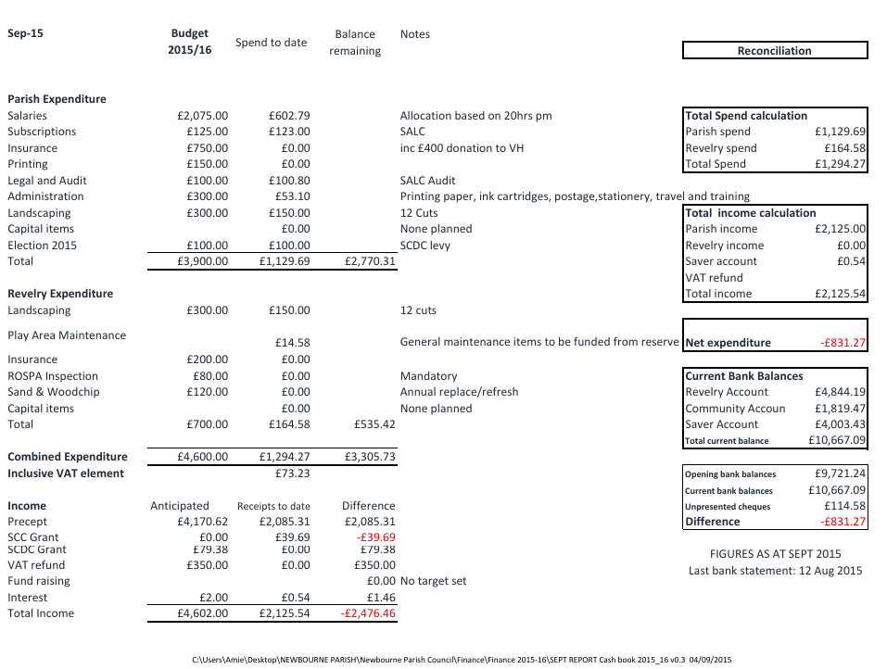

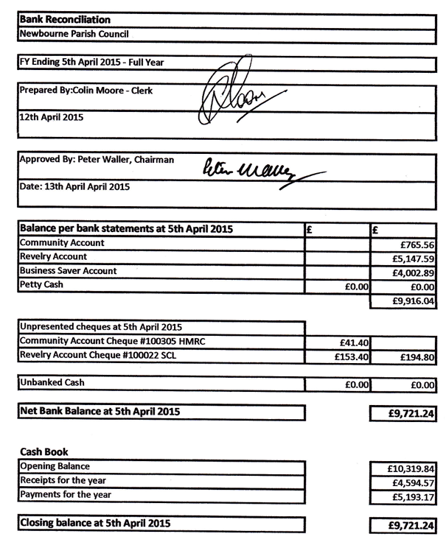
Newbourne Parish Council Record of over £100 spend 2015-2016
Date Paid to Description Payment
13/04/2015 CLERK SALARY £206.79
13/4/2015 SALC SALC SUBSCRIPTION £123.00
20/04/2015 SALC SALC AUDIT £100.80
30/06/2015 CLERK SALARY £275.60
05/07/2015 HMRC HMRC PAYE £120.40
07/09/2015 SCDC ELECTION FEE £100.00
CLERK SALARY £378.95

- Balance brought forward £9721
- Precept £4250
- Receipts money received £1050
£1000.00 grant
£48.00 lottery
£2.00 interest on saving account
39.69 SCC GRANT
- Staff costs - Staff Costs – £1060.18
£24.10, CLERKS EXPENSES
£5.00 LIONEL SCOTT EXPENSES
£206.79 WAGES
£275.60 WAGES
£120.40 HMRC
£49.34 CLERK EXPENSES
£378.95 WAGES
- Loan and interest /capital payments - £0.00
- All other payments - £982.18
£60.00 SCL GRASS CUTTING
£60.00 SCL GRASS CUTTING
£60.00 SCL GRASS CUTTING
£24.00 SALC WEBSITE TRAINING
£30.00 SCL GRASS CUTTING
£60.00 SCL GRASS CUTTING
£60.00 SCL GRASS CUTTING
£14.58 PLAY AREA MAINTANCE
£60.00 SCL GRASS CUTTING
£30.00 GRASS CUTTING
£33.00 ROSPA TRAINING
£30.00 SCL GRASS
£16.80 SALC PAYROL
£30.00 SCL GRASS
£60.00 CLERK TRAINING not cashed
£100.00 SDC ELECTION FEE
£123.00 SALC MEMBERSHIP
£100.80 SALC AUDIT
£30.00 SCL
£41.40 HMRC – UNPRESNTED AS YET
£153.40 SCL REV – UNPRESNTED YET (£194.60)
Section 7 – section 1+2+3 – 4+5+6 = £12,978
Section 8 – total value of cash £12,978
Section 9 – total fixed assets £50,724

