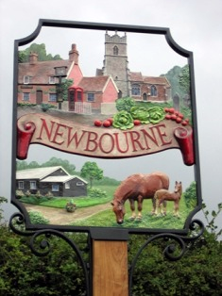

Annual Parish Meeting
Monday 12th May 2025 7pm
- Apologies for absence
- To sign minutes from previous meeting 2024
- Report from Newbourne Village Hall / Financial report
- Report from Chairman
- Reports
- Annual Financial report
- Update Councillors details

Parish council Meeting to continue from Annual Parish Meeting
Public Question Time: At 7.30pm residents are invited to give their views and questions the parish council on issues on this agenda or raise any issues for future consideration at the discretion of the Chairman, before the start of the parish council meeting. Members of the public may not take part in
- Apologies
- Report from District Councillors
- Declarations of disclosable pecuniary interest
- Minutes of Parish council meeting 07/04/2025
- Planning
- DC/24/0857/FUL – Discharge of conditions Nos 6 and 7 of DC/24/0857/FUL – Use of land for the stationing of three holiday lodges -Lodges details and planting scheme -Steading Caravan Park, 10 Ipswich Road.
- DC/25/1676/OUT – Outline application – erection of self-build dwelling – Land adjacent 29 Mill Road
- DC/25/1615/FUL – Construction of two replacement dwellings – Virginia nurseries, Mill Road
- DC/25/1166/ARM – Approval of reserved matters of DC/24/1235/OUT – Outline application demolition of existing dwelling and erection of 2 dwelling with garaging, scale form and appearance of the dwellings, 45 Jackson Road
- Green Infrastructure update
- Finance
Budget report, Cheques to be signed, yearly budget / spend
- Clerk’s job
- Clerks correspondence.

